**Cambridge 17 Writing Task 2 IDEAS**

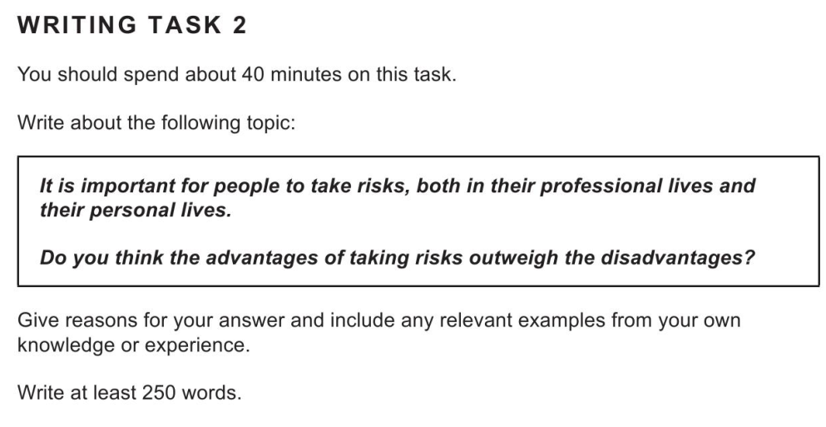

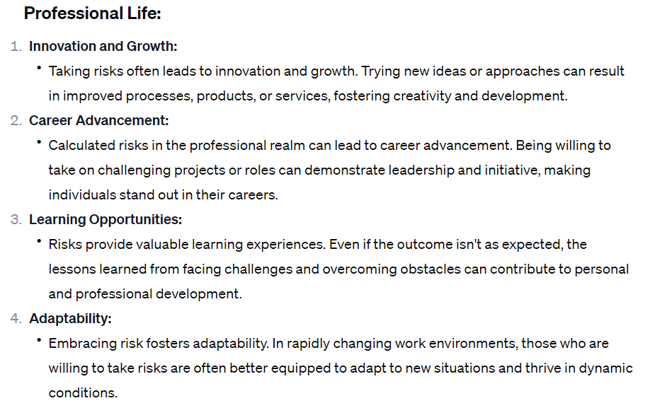

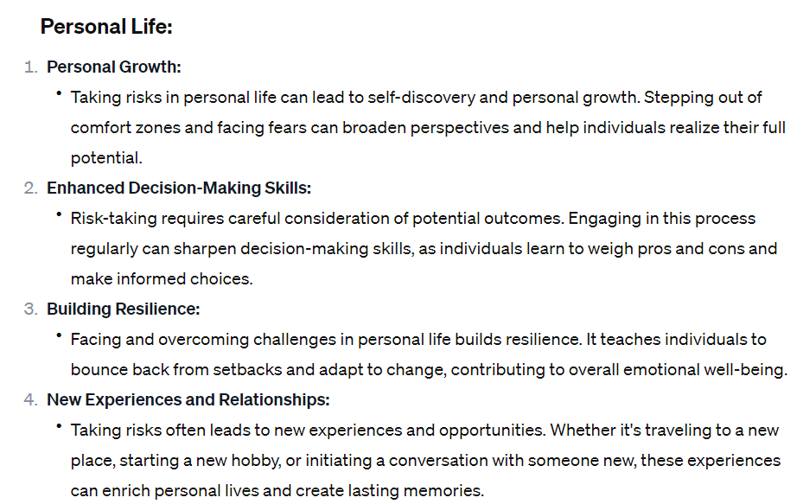

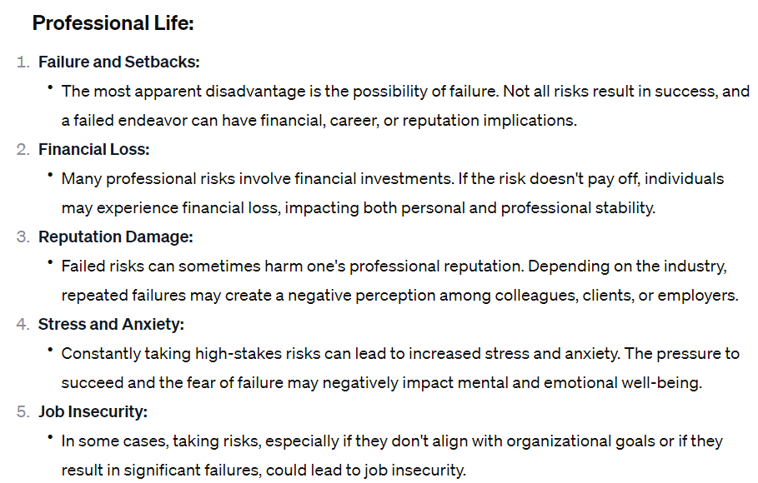

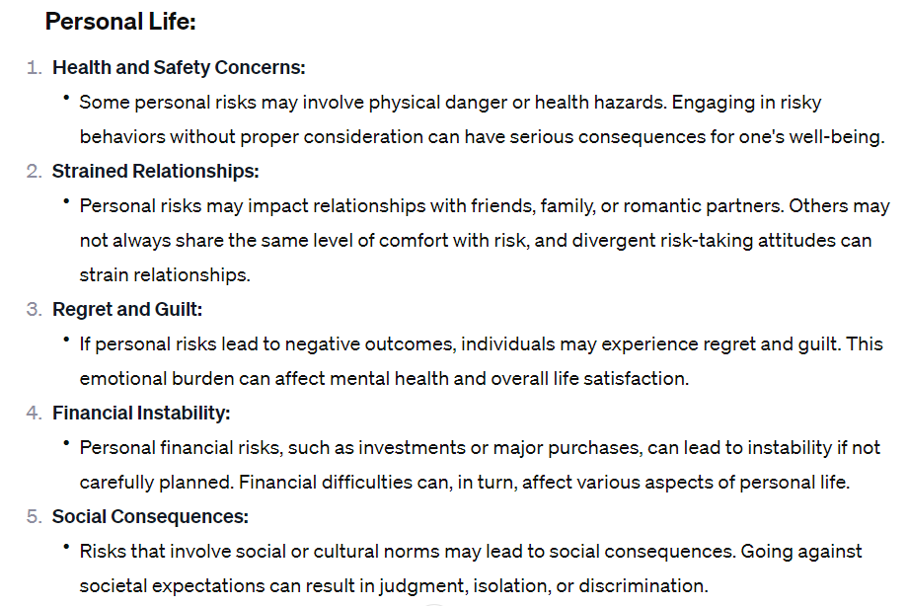

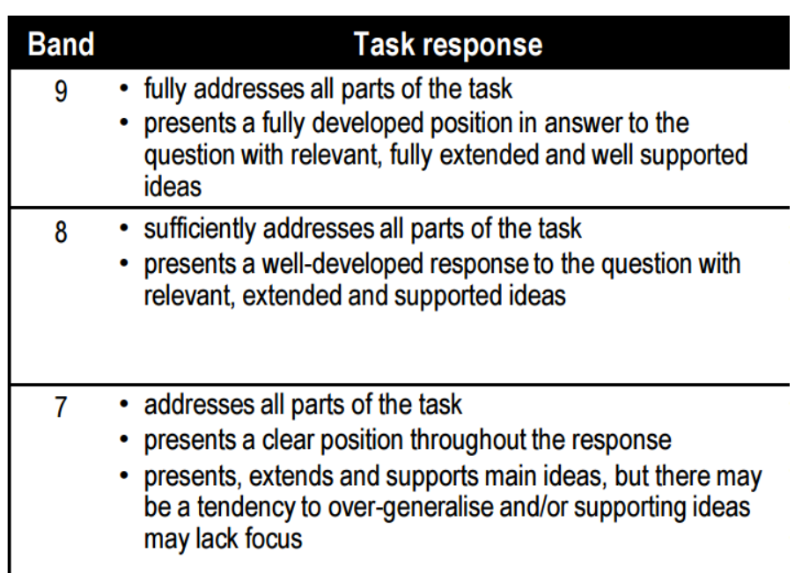

Coherence is when the parts of something fit together naturally. In writing, it is when your ideas are connected together in a natural and logical way. There is a beginning, middle, and end. Your ideas are easy to follow and flow together

Cohesion is the words and phrases connecting your sentences together within your writing. Each sentence connects well grammatically to the next, from start to finish.

**Topic Sentence**

A good way to create coherence is to have a topic sentence in each body paragraph introducing the idea within the paragraph and how it connects to the main topic. This helps with readability and reader comprehension.

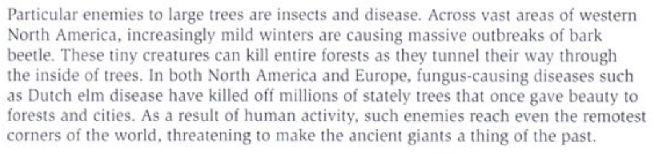

**Cohesive devices**

Cohesive devices are all the words and phrases used in writing to connect sentences and ideas together. Words such as however, moreover, and in conclusion, are used frequently by candidates when writing Task 1 or Task 2.

well. 